3.2 Functions of Two or More Variables Worksheet

- Let . Determine the limits in the problem below. Make sure you write a full argument to justify your position.

- Determine .

- Determine .

- Determine

- Determine whether each of the following limits exists. Make sure you write a full argument to justify your position.
- .

- .

- Consider the following piecewise functions and determine .

- Hint: Consider the path at some point.

- Let F be a function of x and y. Consider the following statements.
- as along every straight line through , but does not exist.
- as along the lines and , but does not exist.
- as along the lines and , but .

Which statements could possibly be true?

- Mark exactly one box corresponding to the correct ending of the sentence.
“The limit …
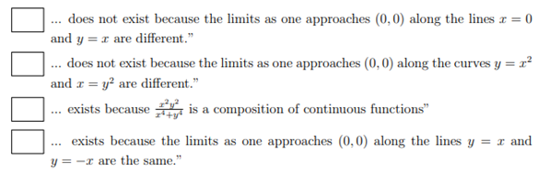

- Let f be a function from to . Suppose that as along every line of the form . What can you say about the limit ? Select all that apply.
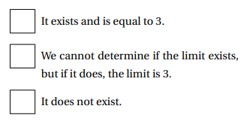

- Determine 5 different paths along which you can compute the limit .

- Calculate the following limit.

- Is the function continuous at ?

